Dharma Devi-Home Work 3

1.Creating a Bucket

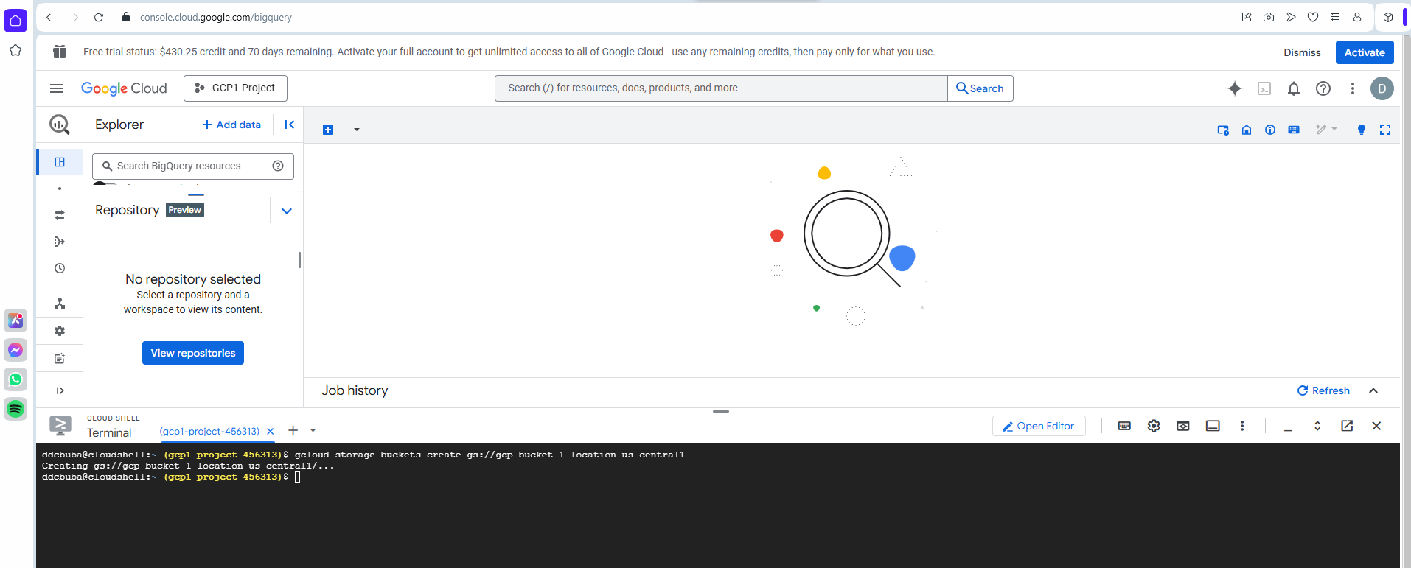

Task 1:Create a Dataset in BigQuery

Added Nyctaxi dataset

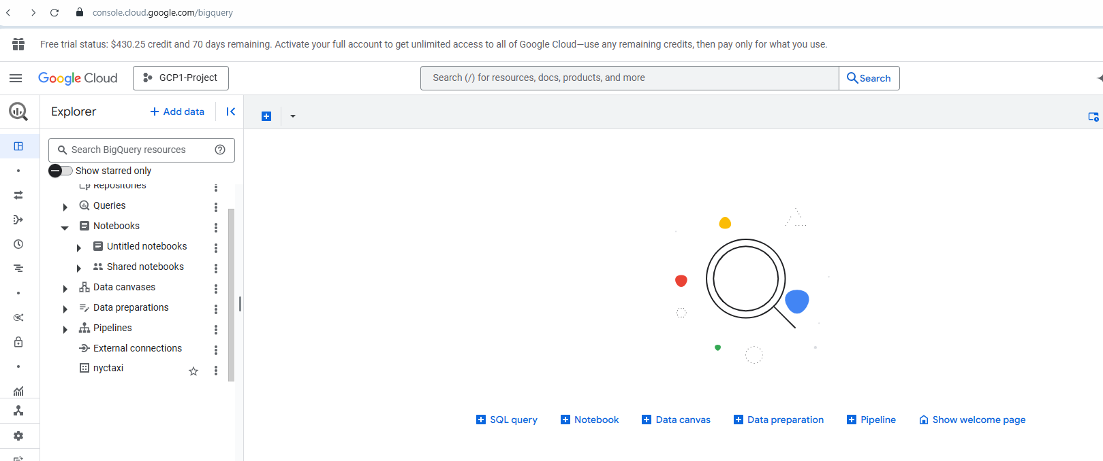

Task 2:Load a CSV File in BigQuery

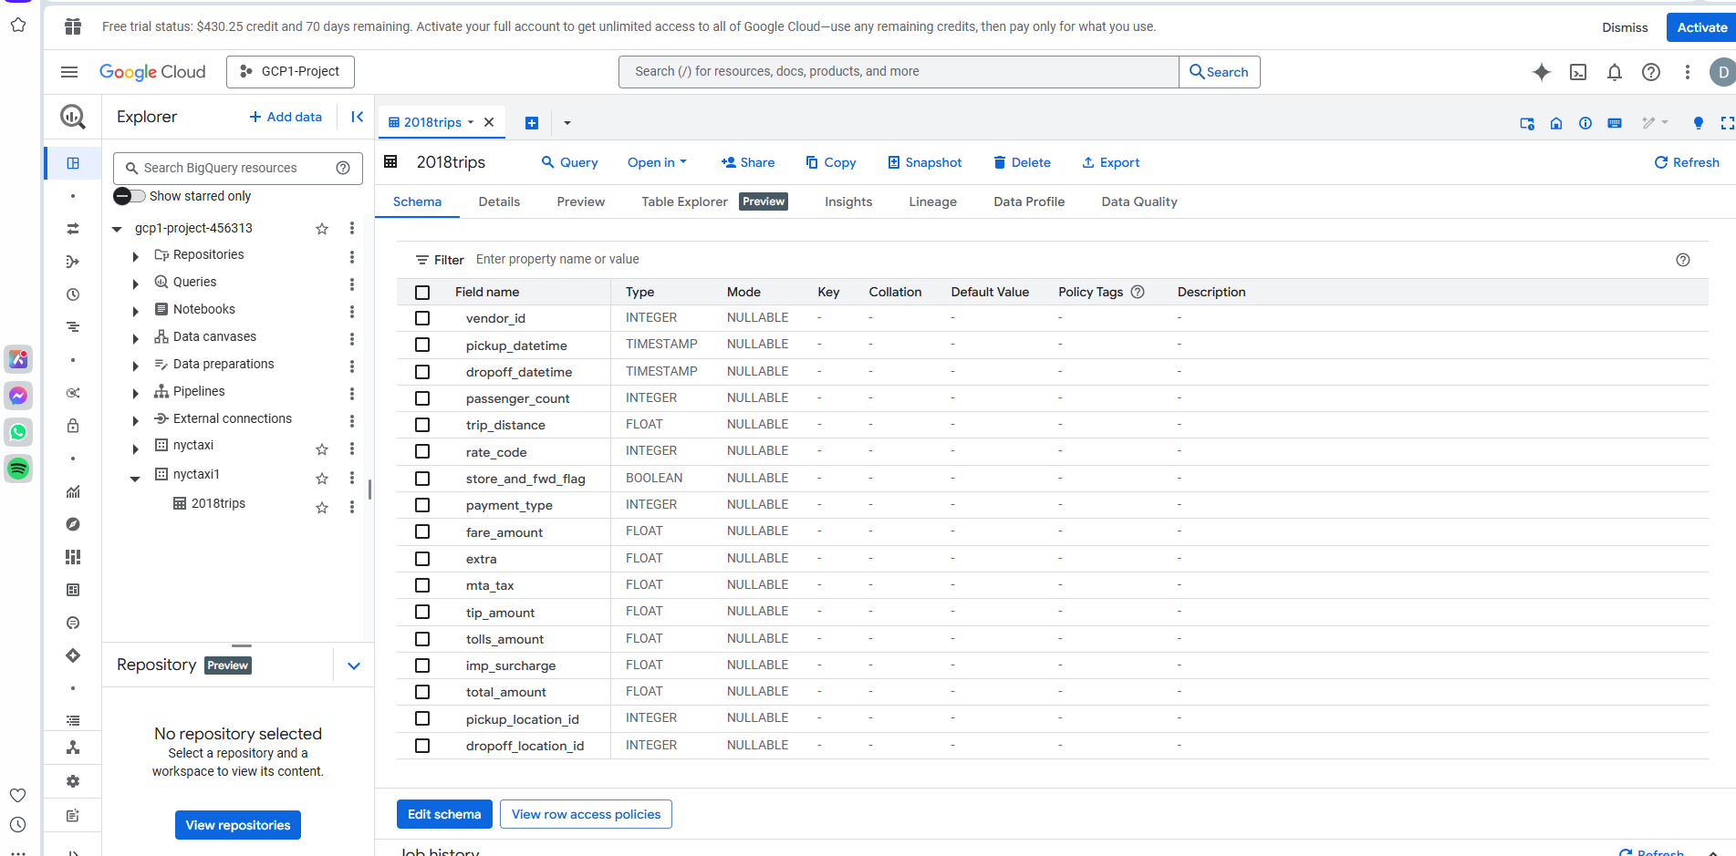

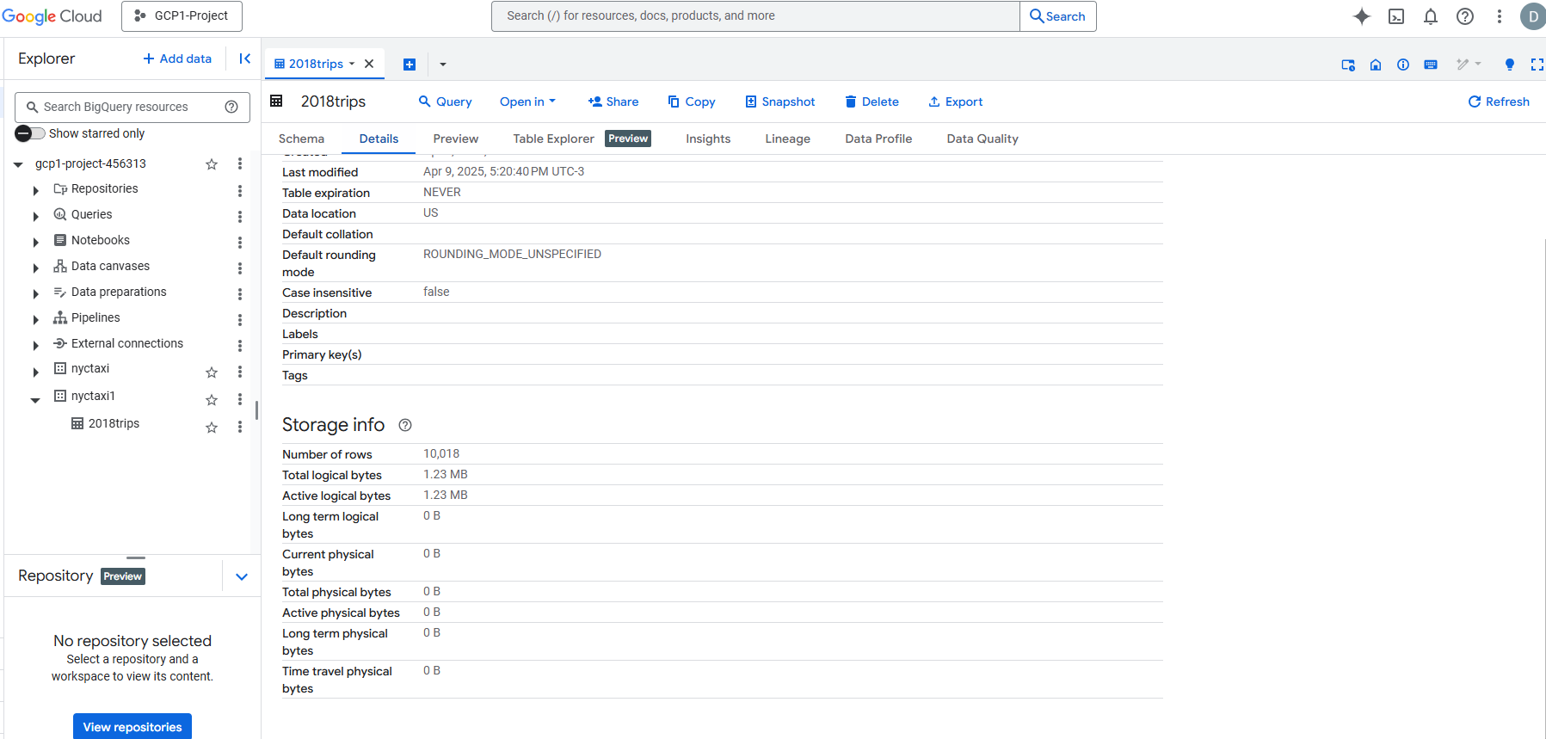

**Task 3:Query the BigQuery Table**

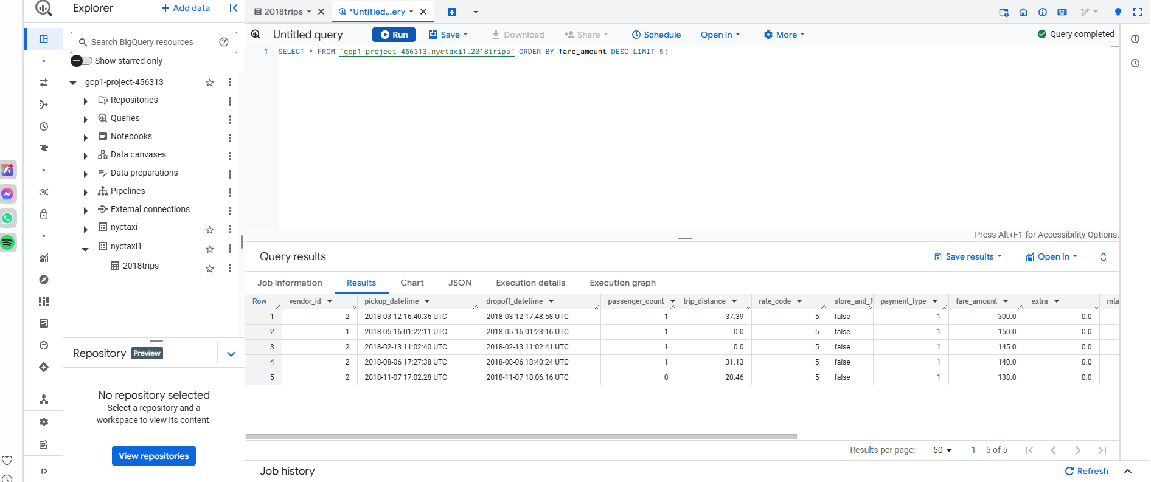

**TASK 4:LOAD MORE DATA from Google Cloud Storage(via CLI)**

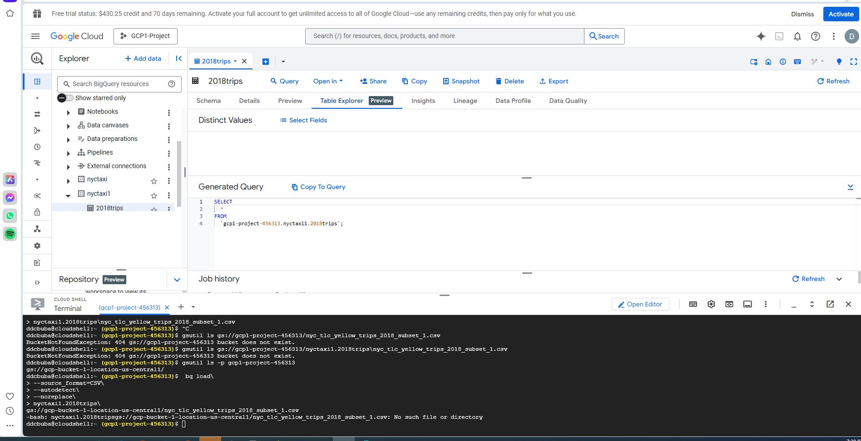

**Task 5:Use DDL to create a New Table from Existing Data**

**Create Table nyctaxi.january_trips AS**

**SELECT \***

**FROM nyctaxi1.2018trips**

**WHERE EXTRACT(MONTH FROM pickup_datetime)=1;**

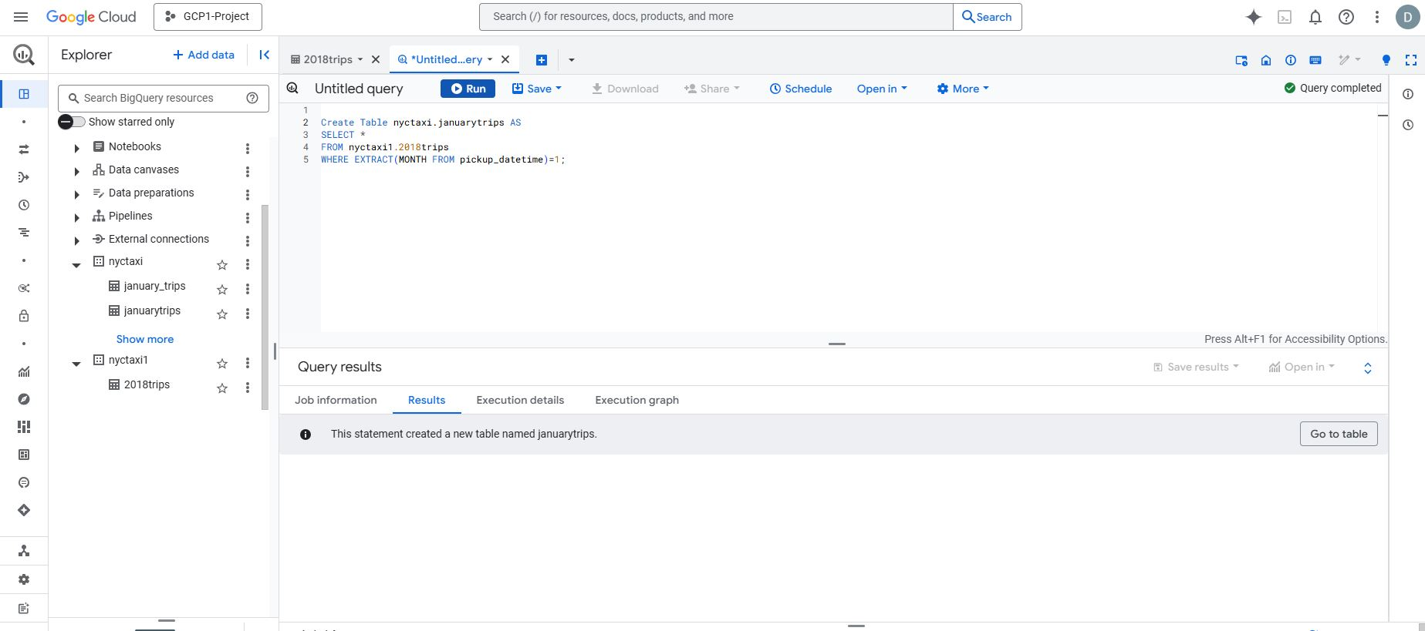

**2.Run a query to find the longest trip in January**

**SELECT * FROM nyctaxi1.january_trips**

**ORDER BY trip_distance DESC**

**LIMIT 1;**

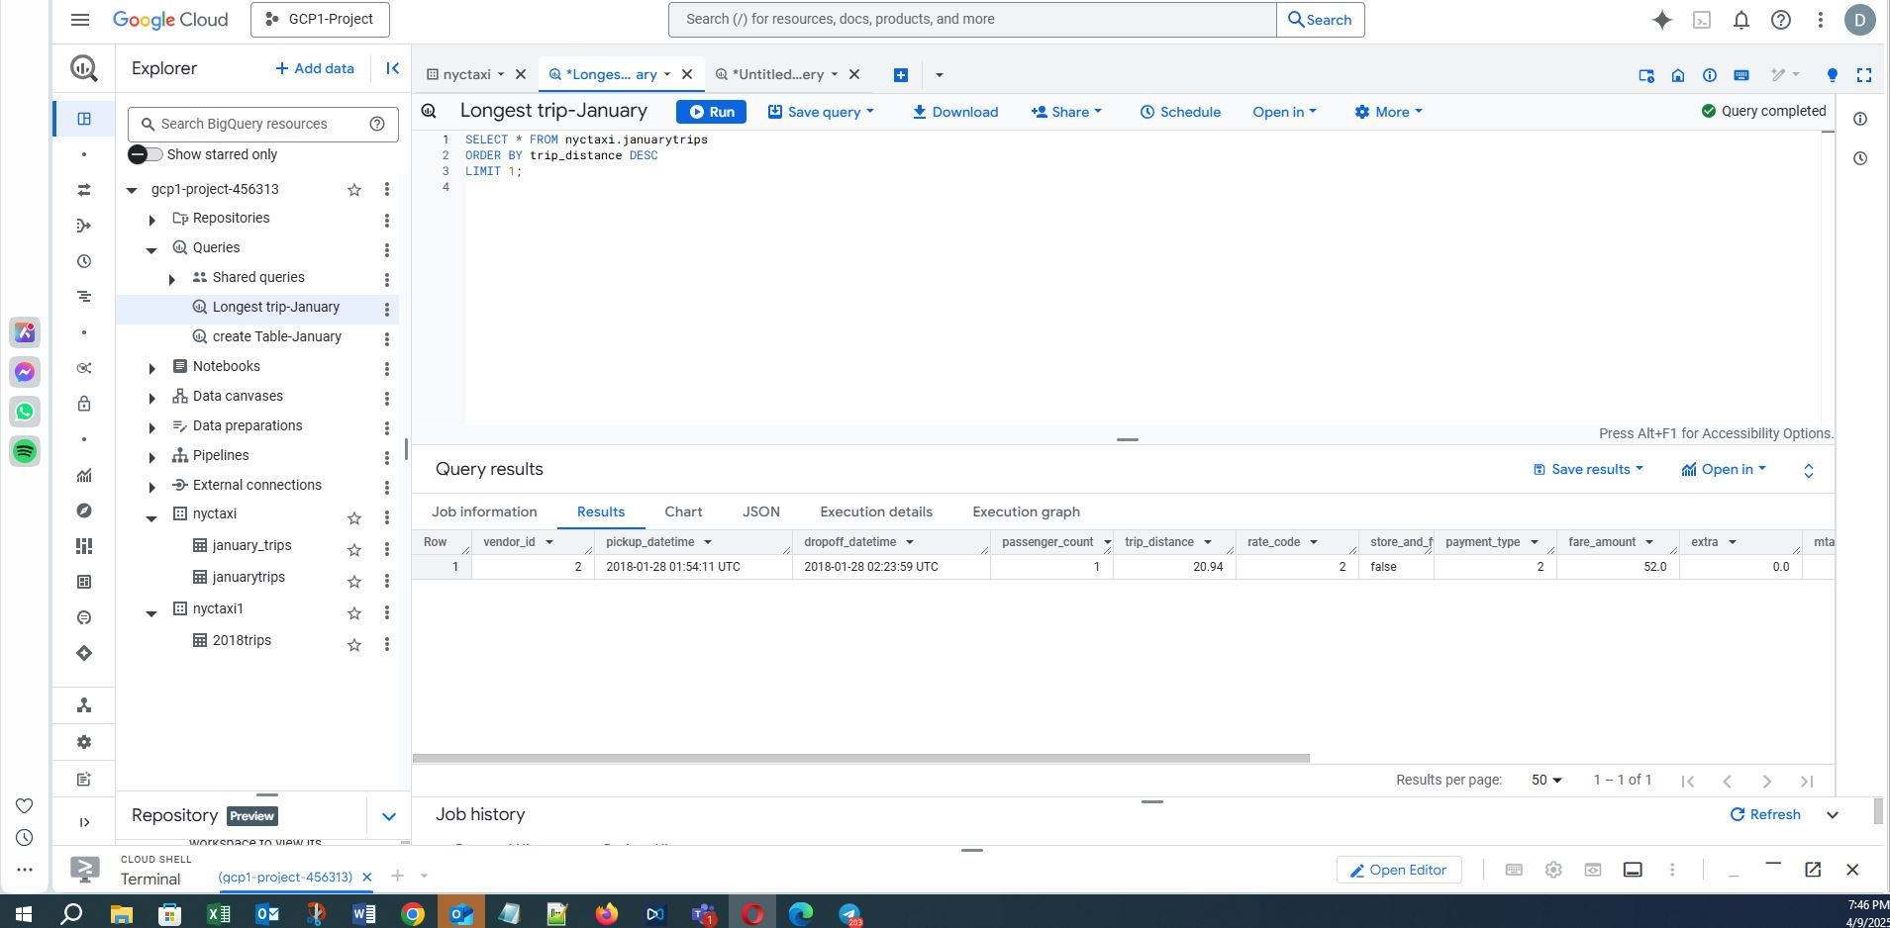

**Task 6:DATA ANALYST**

**1.Trip Count by Vendor**

**Write a query to find the total number of trips taken by each vendor_id**

**SELECT**

**vendor_id,**

**COUNT(*) AS total_trips**

**FROM**

**nyctaxi1.2018trips**

**GROUP BY**

**vendor_id;**

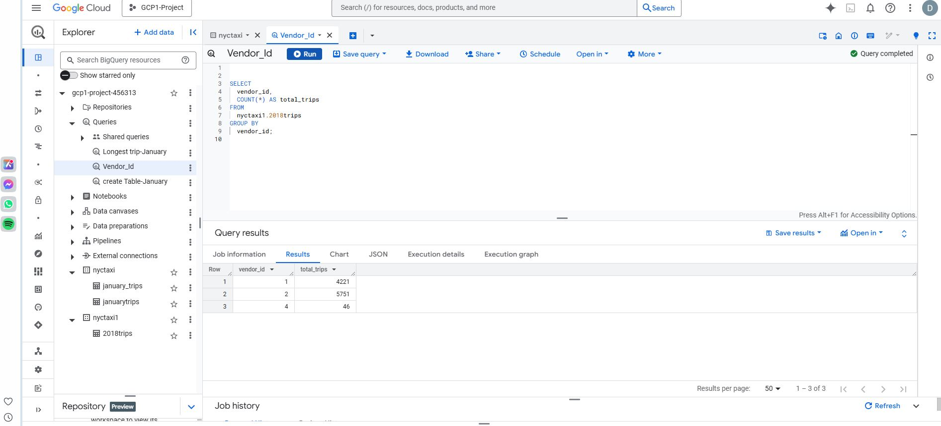

**2.Highest Earning Payment Type**

**Calculate the total fare amount collected for each payment_type**

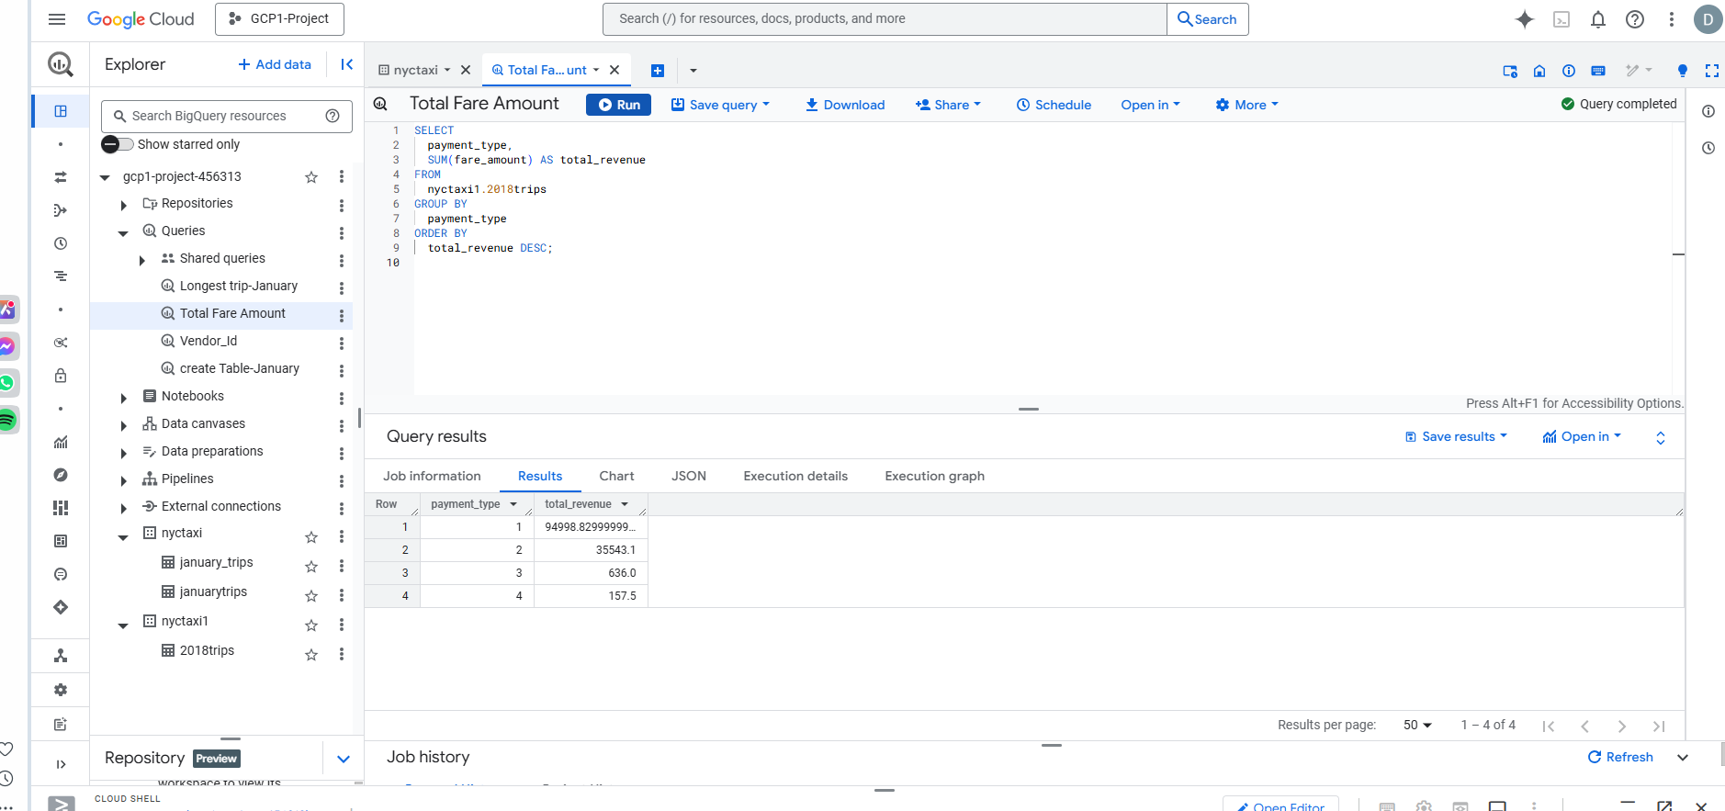

**1.which payment type generated most revenue**

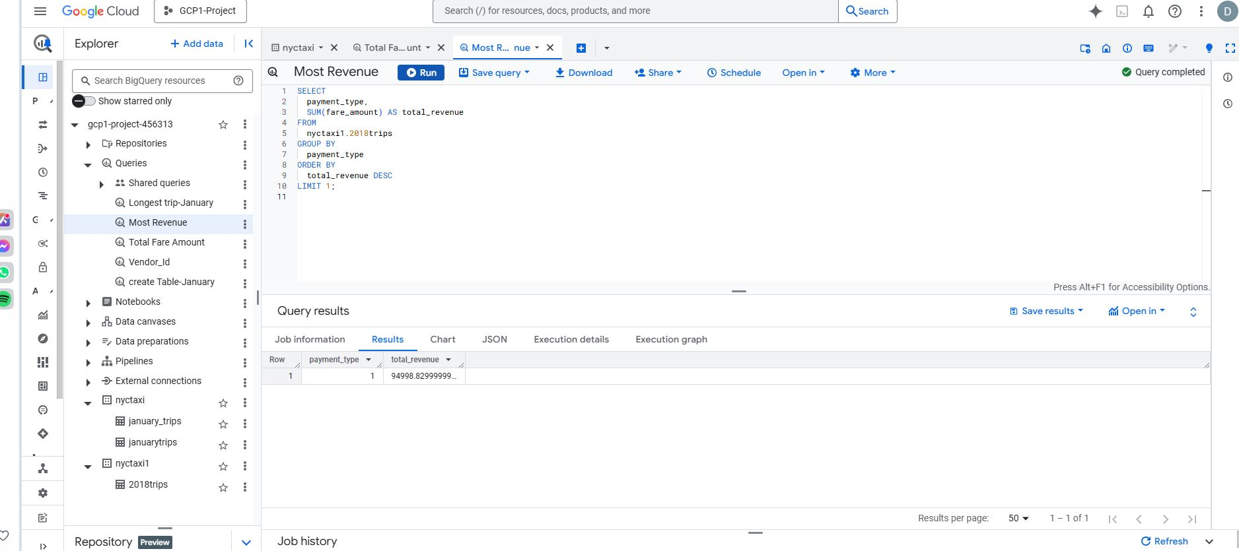

**2.sort the results by total fare amount**

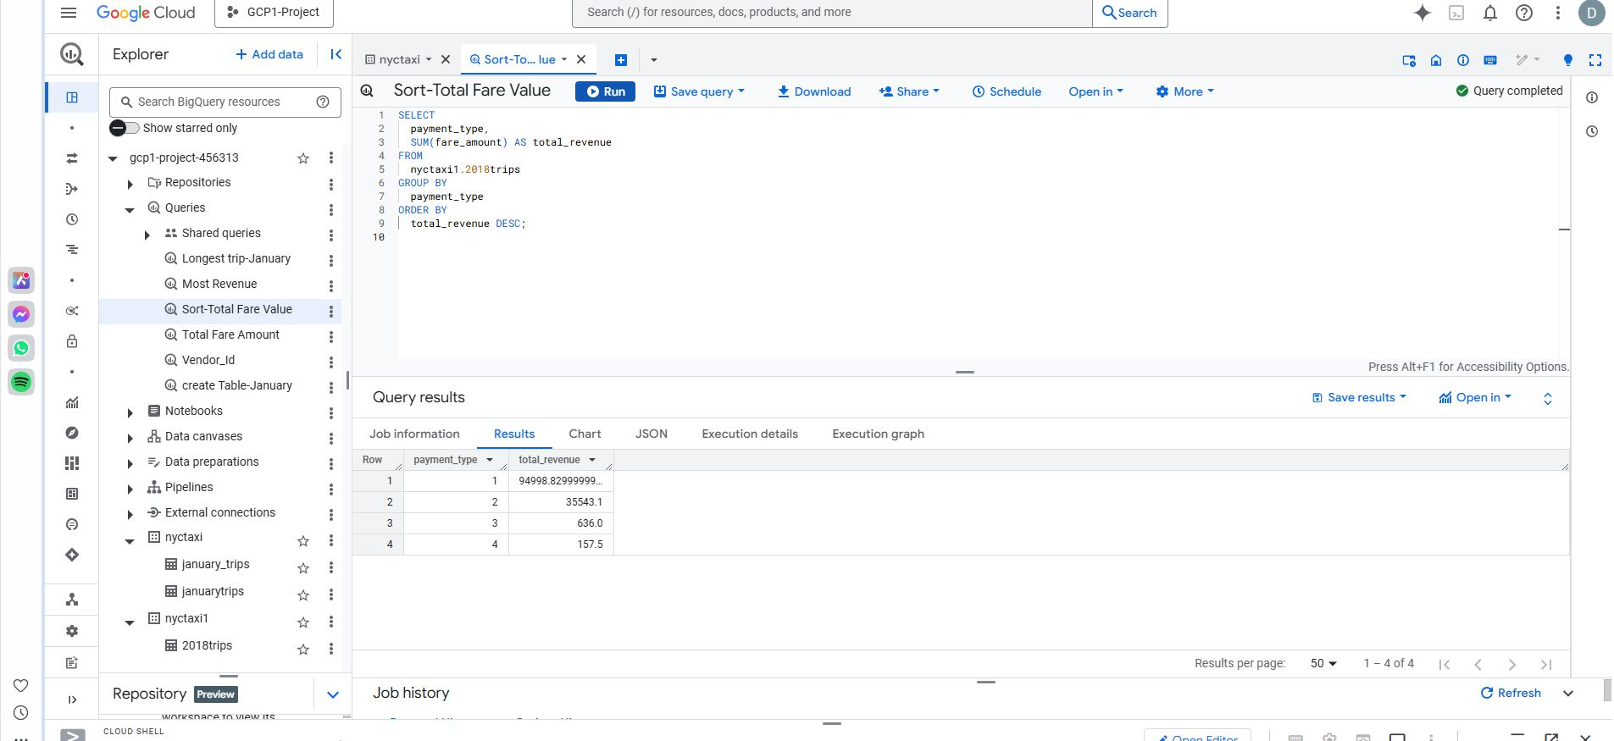

**3.3. Top 5 Longest Trips**

**List the top 5 trips with the longest trip_distance.**

**●**

**Include pickup_datetime, dropoff_datetime, trip_distance,**

**fare_amount, and payment_type.**

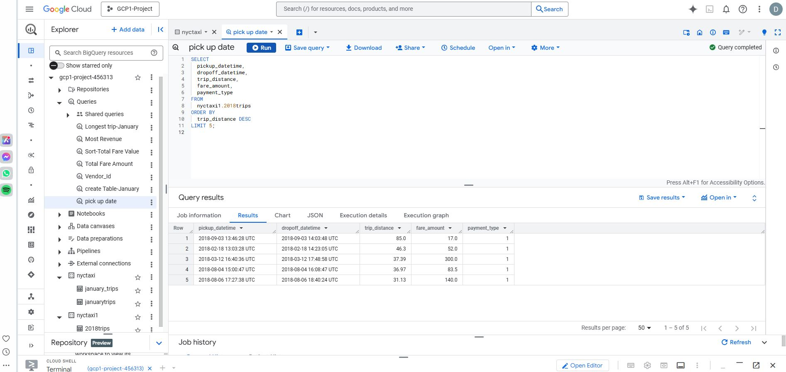

**4. Monthly Trip Trend**

**Find the total number of trips per month for the year 2018.**

**●**

**Extract the month from pickup_datetime and group by it.**

**●**

**Sort the results by month.**

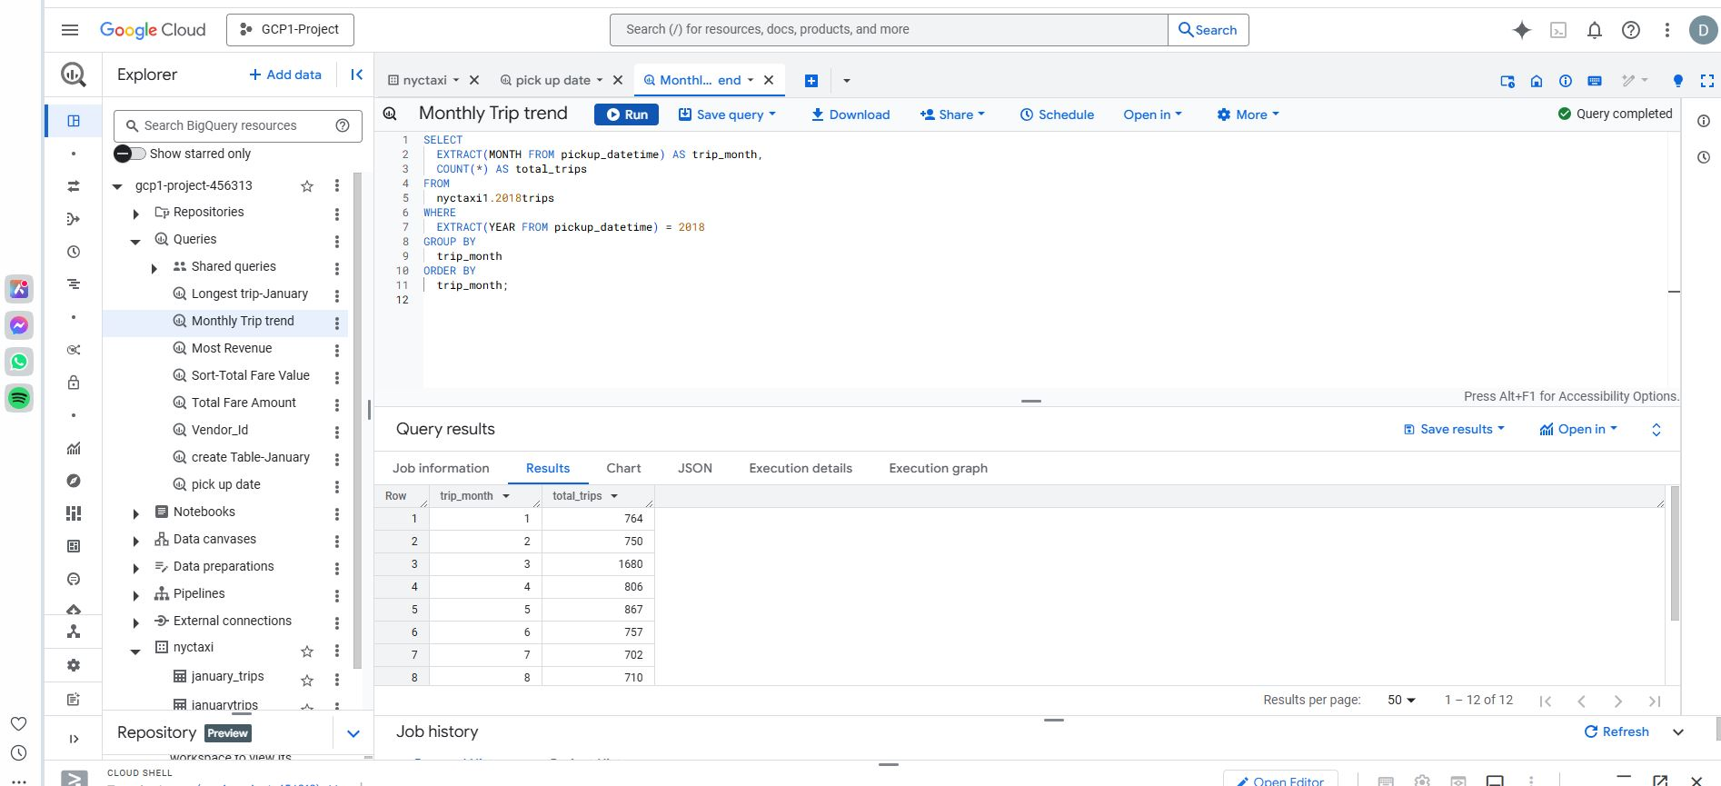

**5. Tip vs. Fare Analysis**

**Find the average tip amount and fare amount for trips where the tip was greater than $5.**

**●**

**Include the average tip_amount, average fare_amount, and the number**

